## --------------------------------------------------------------------------------------------------------------------------------------

## CS5590 Web-Mobile – Lab 2 –Report

## #26, Avni Mehta

## --------------------------------------------------------------------------------------------------------------------------------------

Task 1 Objective:

To create an online news app that makes asynchronous calls to API – BBC News API and displays the news results.

Code:

1. **Html page**

The launch page called home.html. This page toggles between Login and Register. The login behind login and register is not implemented as it is not in the scope.

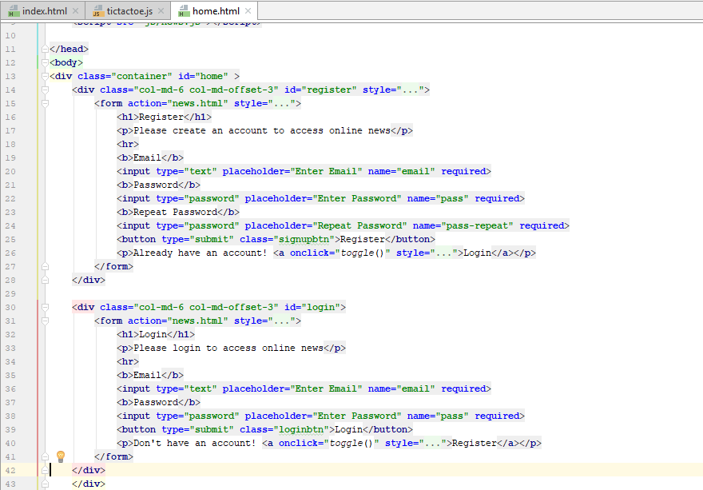

The search page(news.html) consists of two criteria by which a user can search news. They are search topic and news source. At least one of the search criteria needs to be selected. The news is displayed as heading, time and image. On clicking the image, the news article opens in a new tab.

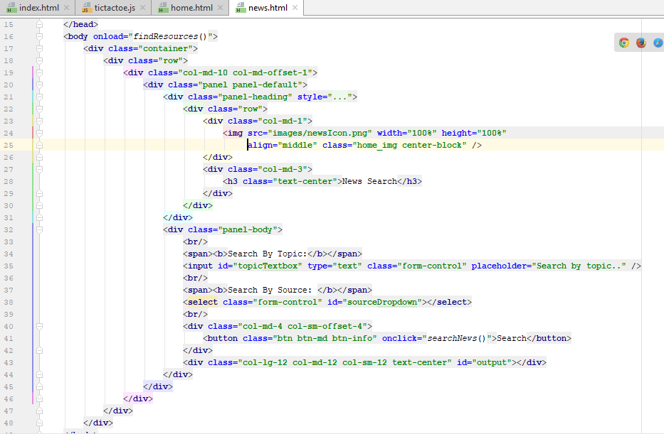

1. news.js (Javascript)

This javascript contains all the code behind toggle of login/register page, API call using ajax, error messages etc.

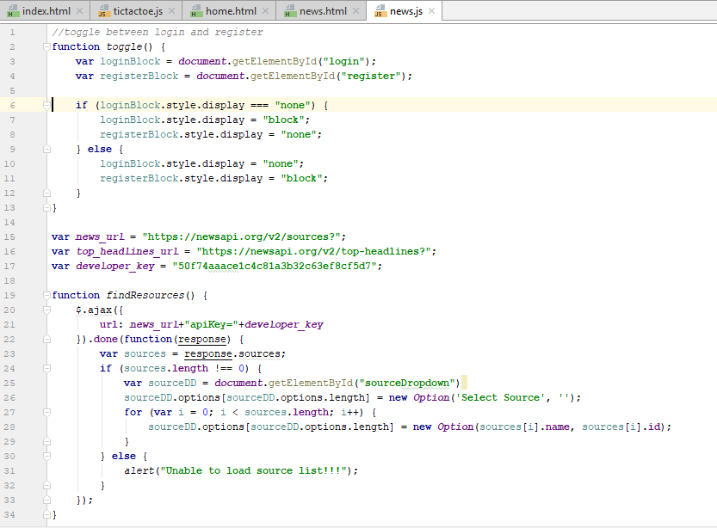

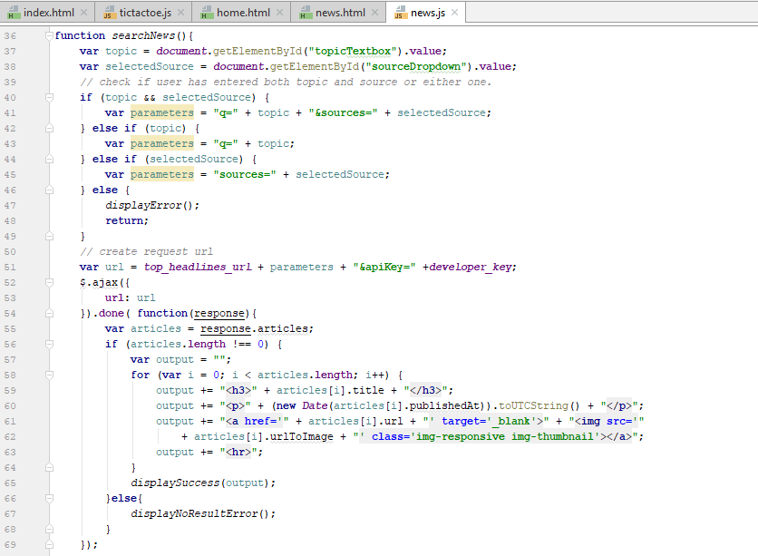

Output:

When the page loads.

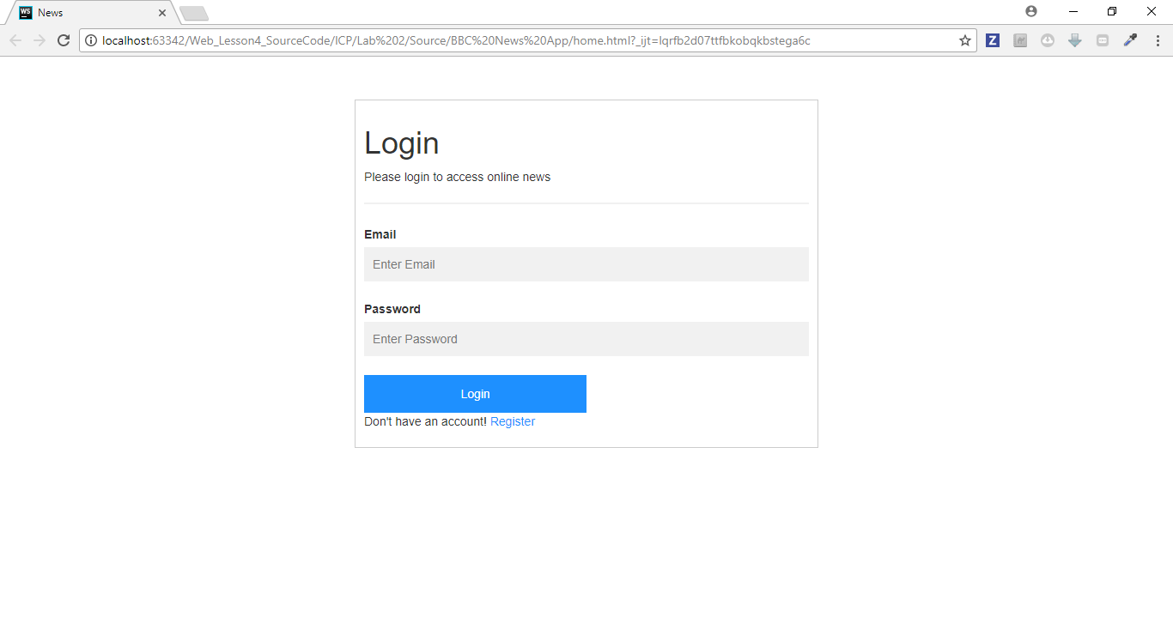

Toggle when user clicks on Register

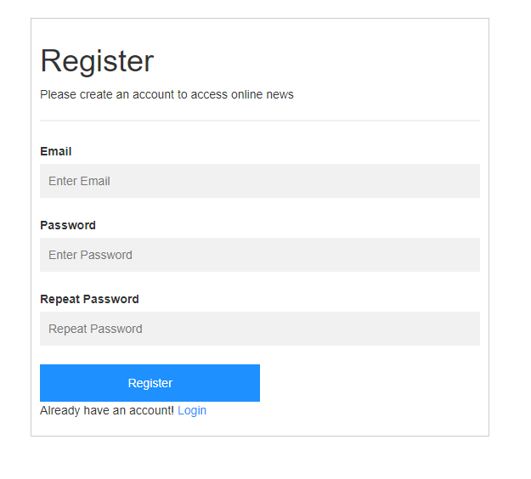

Login page logic not implemented, still all the mandatory fields needs to be entered.

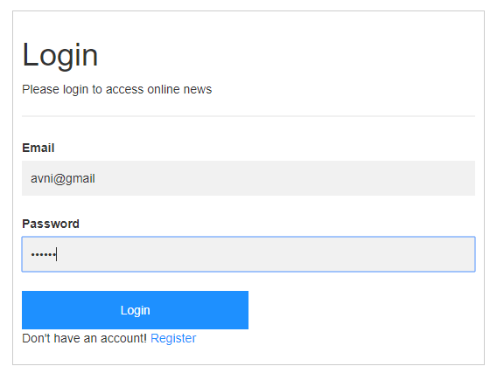

When the user logs in or registers, the news page is loaded.

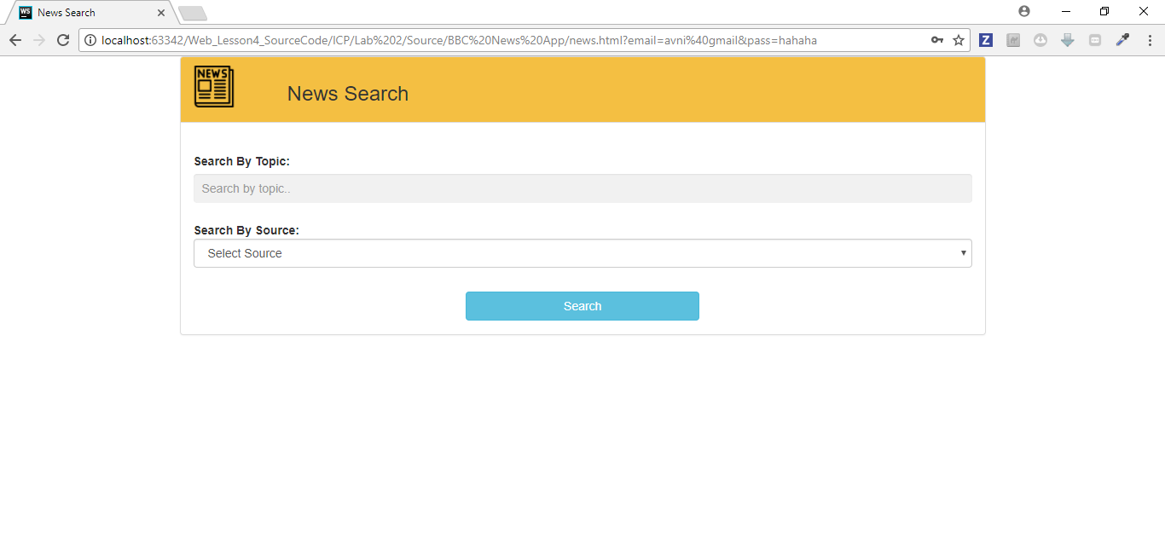

At least one criteria needs to be selected.

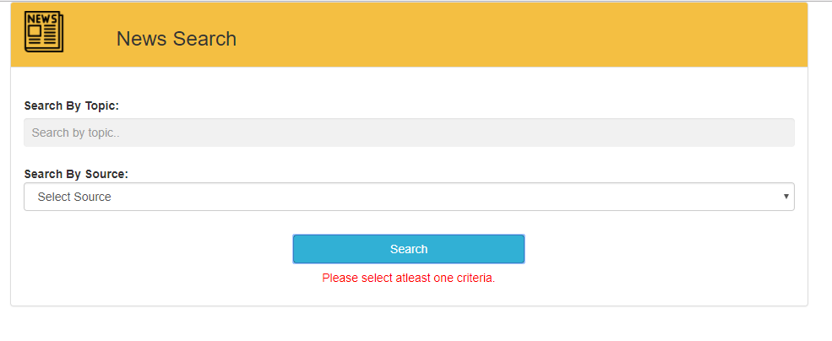

A proper message is displayed when no results are found

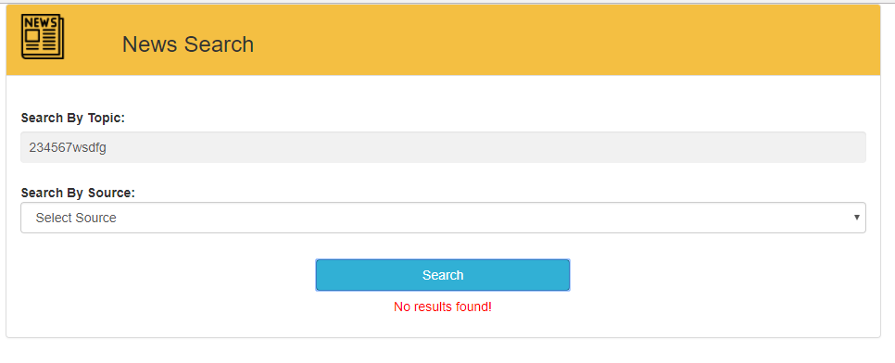

News being displayed on the page

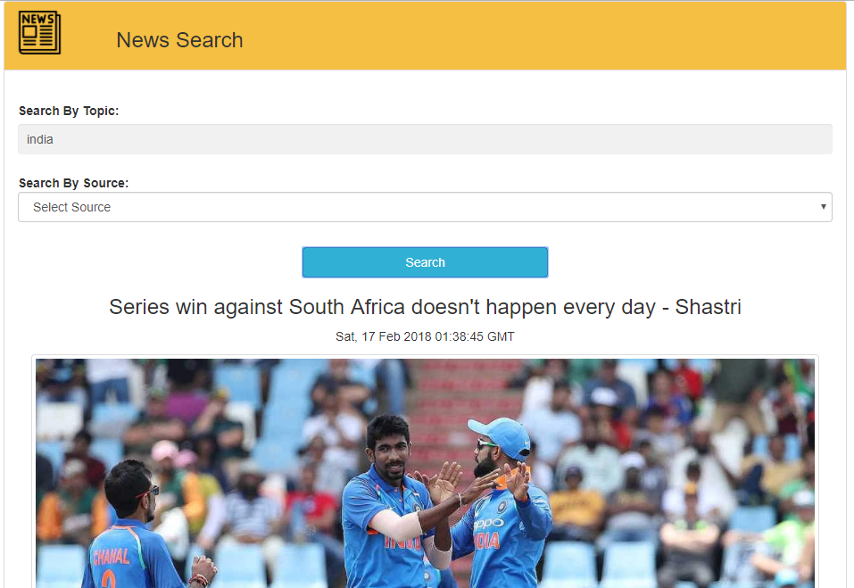

When the user clicks on image, the article is displayed in new tab.

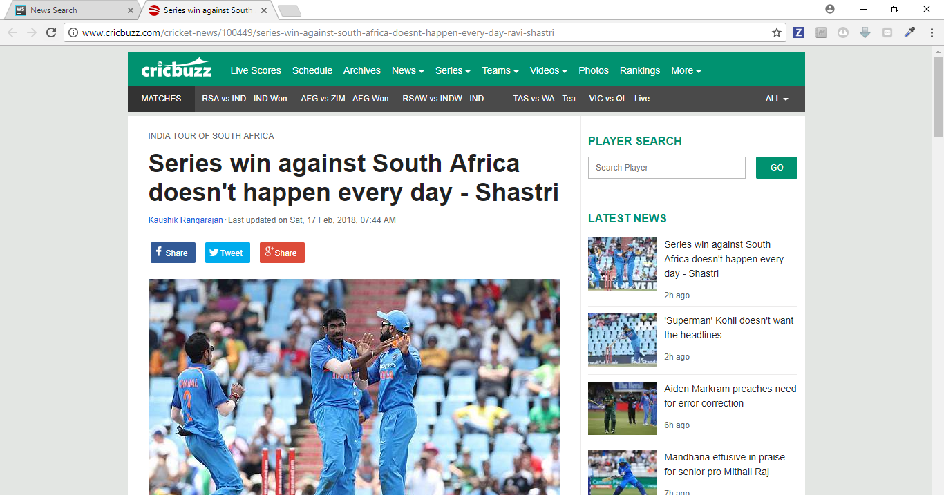

Task 2 Objective:

Tic-Tac-Toe game using Angular JS.

Code:

a. HTML page

The html page contains the board with angular js element ng-repeat. The page displays the current player when game is in progress. When the game is complete, it displays the results along with an option to play a new game.

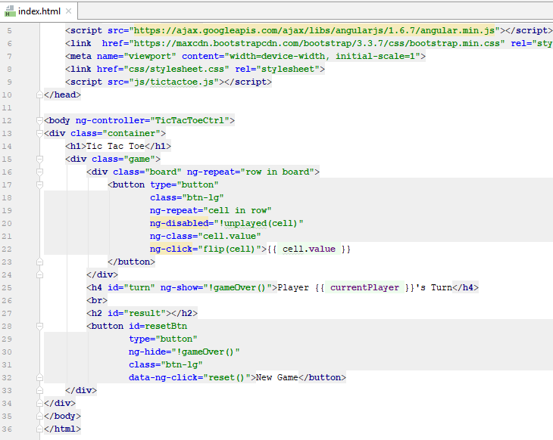

b. Javascript page

This page consists of all the game logic to set and reset the board when started. It checks if the game is over by checking rows, columns, diagonal and tie-case. It also contains the logic to flip a cell.

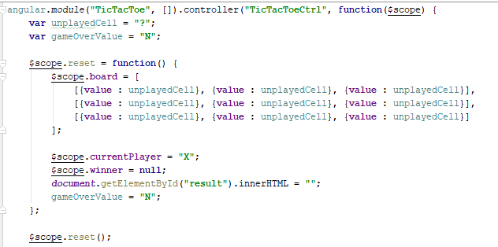

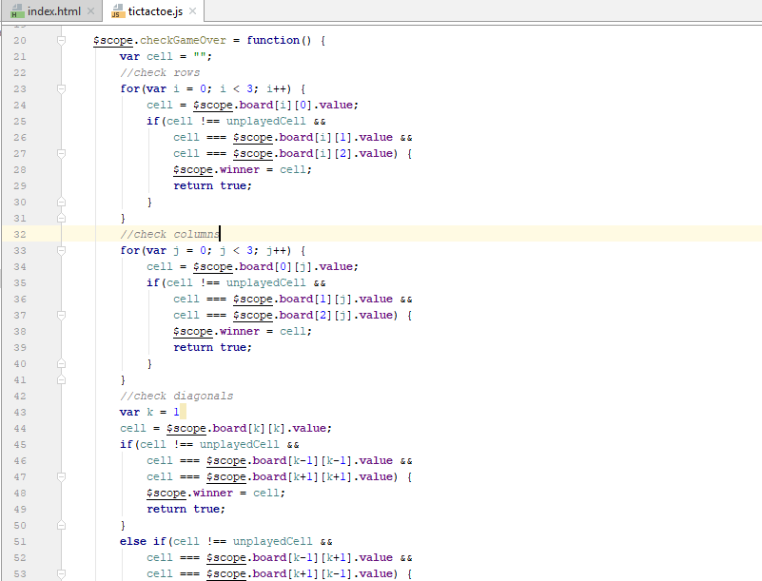

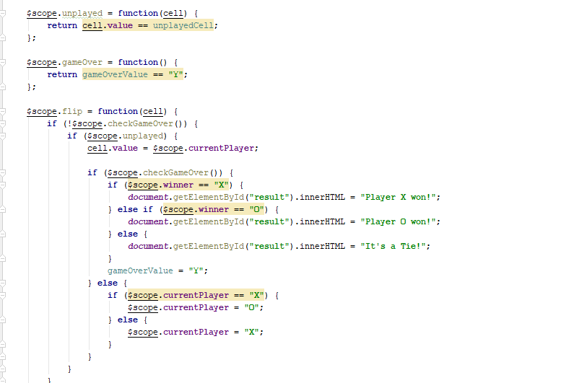

c. css page

The css page contains code for styling and displaying the elements.

Output:

Home page. The game starts with player X’s turn

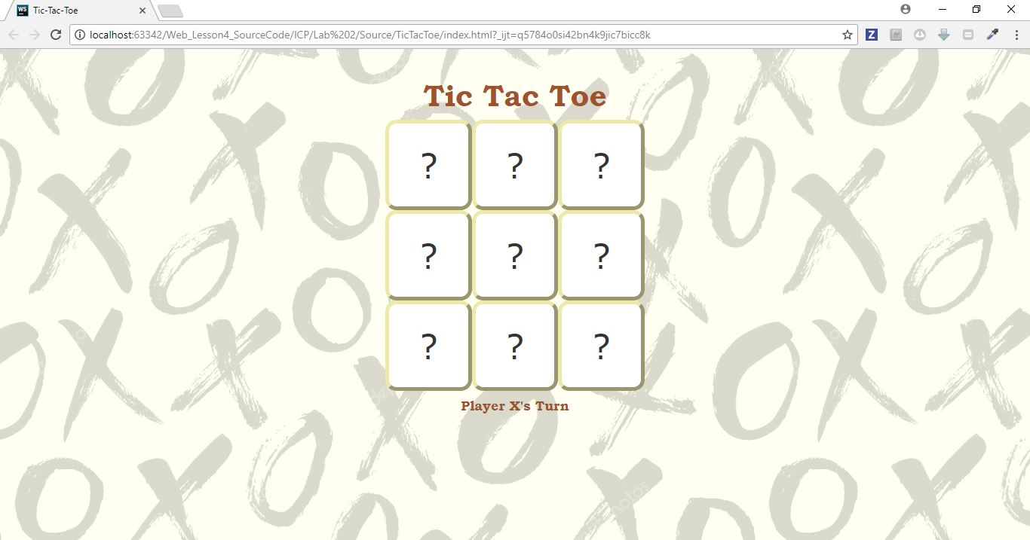

After a tile is clicked, message displays “Player O’s turn”

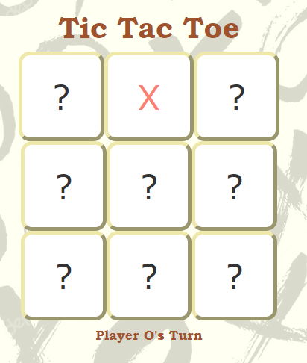

Diagonal win – Message displays who won. Also a new game button is enabled.

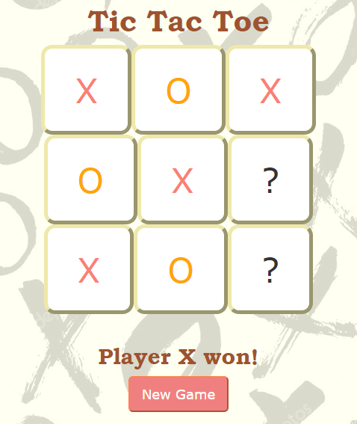

Horizontal win

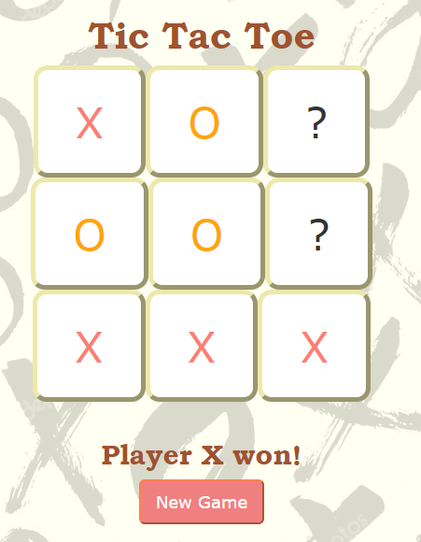

Tie situation.

